GEOGRAPHY
Task 1. Lahemaa National Park
Aim: to describe the geographical location of the national park
Integrated subjects: biology, geography, physics, math
Equipment: A4 paper, a ruler, a calculator
Instructions: Describe the geographical location of Lahemaa National Park using the maps and the following plan:
1. The name of the national park,
2. What parts and regions of the country it locates in.
2. Its approximate measurements (width and length).
3. Depict its coastline.
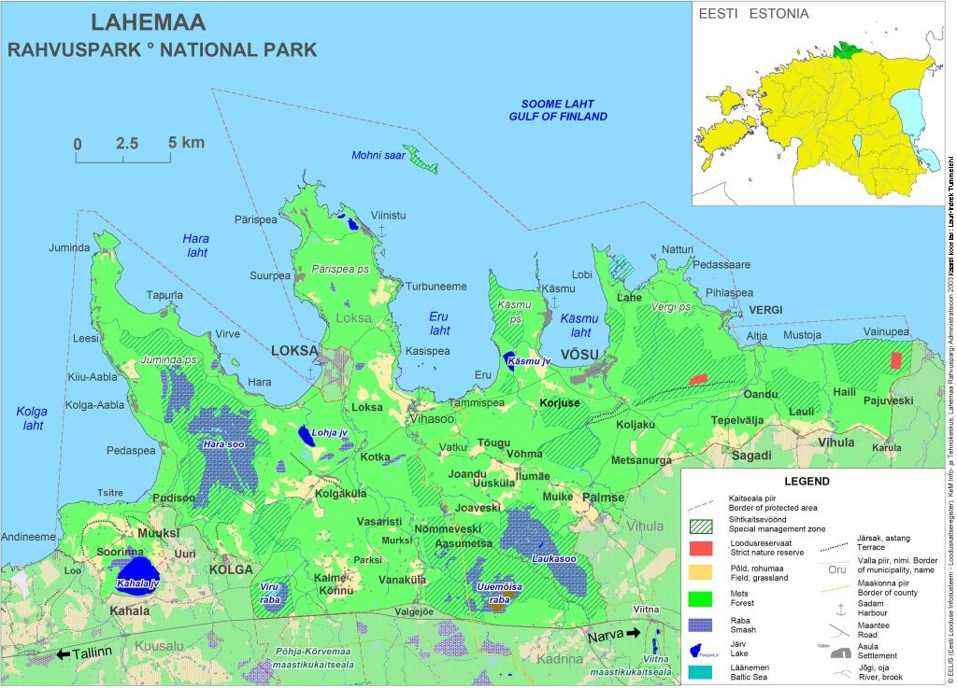
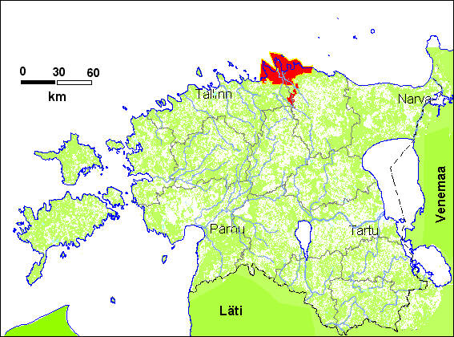 | 