PHYSICS
Task 3: Measuring Density Of Humid Wood
Aim: Define the density of various species of wood (pine tree, birch tree, fir tree) in this area.
Integrated subjects: Biology, Chemistry, Geography, Physics.
Equipment: weight scale, knife or wood saw, measuring glass
I Measuring the samples of different tree species
Equipment: weight scale, 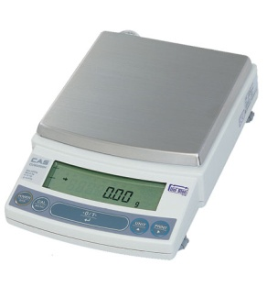
Instructions:
- Take the samples (a branch of cylindrical form, length up to 10 cm) of different wood samples (3 samples of each species)
- Clean the bark
- Measure the weight of each sample (without bark): m₁, m₂, m₃
Table 1 Weight of samples
Wood species | Weight of sample 1, m₁(g-gramme) | Weight of sample 2, m₂(g-gramme) | Weight of sample 3, m₃(g-gramme)
Fir tree
Pine tree
Birch tree
Student’s option
Student’s option

II Measure the body volume by method of dipping
Equipment: measuring glass, needle or pin, clamp or peg

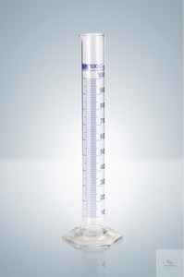 | 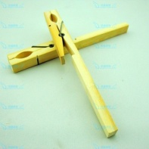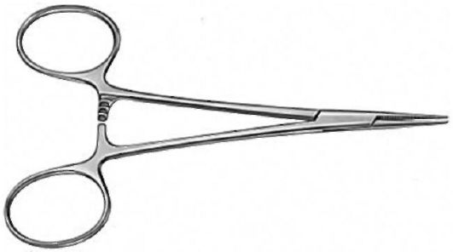 | 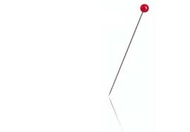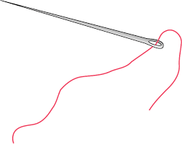
measuring glass | clamp or peg | needle or pin

Method of measuring the body volume by dipping (immersion):
A) measure the initial volume of water in the measuring glass V₀
Initial volume V₀= ................ ml
B) Force a needle into the wood sample on the side of the cutting
C) Clamp the tail of the needle with a clamp or peg
D) Dip the sample into the measuring glass with water ( the sample is fully dipped into the water)

E) Measure the water volume in the measuring glass after the dipping of wood sample V₁
Water volume V₁=………………………………. ml
F) The sample volume is the difference of water volumes before and after the dipping V_{sample}=V₁-V₀
Sample volume V_{sample}= .................................... ml
G) Converse sample volume into cm³, knowing that 1 ml = 1 cm³
Sample volume V_{sample}= .................................... cm³

Instructions:
- Measure the volume of samples by dipping and record the results into the table

Table 2 Volume of samples
Wood species | Volume of sample 1, V_{sample1} (cm³) |  |  | Volume of sample 2, V_{sample2} (cm³) |  |  | Volume of sample 3, V_{sample3} (cm³)
Fir tree | V₀ | V₁ | V_{пр1} | V₀ | V₁ | V_{пр2} | V₀ | V₁ | V_{пр3}
Pine tree
Birch tree
Student’s option
Student’s option

III Calculation of density of humid wood
Instructions:
- Using the data of table 1 and table 2 calculate the density of wood using the formula:
$ρ=\frac{m}{V}$ , where
m – weight of wood sample (g);
V – volume of wood sample (cm³);
Ρ- density ($\frac{g}{{cm}^{3}}$)
- Record the results of calculation into table 3
Table 3 Density of wood species
Wood species | Density of wood species ($\frac{g}{{cm}^{3}}$)
Fir tree
Pine tree
Birch tree
Student’s option
Student’s option

IV Compare the densities of various wood species and conclude
Comparison:
……………………………………………………………………………………………………………………………………………………………………………………………………………………………………………………………………………………………………………………………………………………………………………………………………………………………………………………………………………………………………………………………………………………………………………………………………………………………..
Conclusion:
……………………………………………………………………………………………………………………………………………………………………………………………………………………………………………………………………………………………………………………………………………………………………………………………………………………………………………………………………..

