Natural Science Excursion Jaklamyra 9/9-15
Purpose:
The purpose with the excursion is to examine the 4 ecosystems in the area and assess which phase these ecosystems are in.

Equipment:
- Florabooklet and flora book
- Insect book
- Pen/pencil
- Camera (mobil phone)

Method:
We started in area 4. We made an overall observation of the areas and the environment of the vegetation. Furthermore, we assessed the light, moisture and wind conditions for the plants. In addition we made descriptions of the areas and the flora with height of the different species.
We answered the same questions for all areas, and we took pictures of each ecosystem and most species in the area of 1 x 1m. The flora booklet helped us charaterize the species in the different areas. In the end we assessed the overall succession prosess in each area. We were to find information about some species in each ecosystem.

Observations in area 1: Field with tall perennial community and various brush vegetation on the outskirts
The ecosystem is in the latter pioneer phase. The brush vegetation is spread out. The ecosystem includes a tall pioneer community of different species of plants. This field is not in a climax phase, because there som deciduous forest around the field. As time goes by, thicket of small trees will compete with the field flowers and settle in to a consolditating area of a more mixed community. The tall pioner plants will disappear and die. They will rot and become nourishment for the trees. Bacteria and fungii will break down the noutrients to mineral and ions for the trees.

Light conditions | Light conditions - very good.
Moisture | Dry ground, no rain for a week.
Descriptions of environment | Gravel was dumped by humans in the area. Vegetation is about 1 meter high. Late in primary succession phase.
Plant species | Rasberry, Tansy (Tanacetum vulgare, nettle, willowherb Epilobium hirsutum, coltsfoot(Tussilago farfara), red clover (Trifolium pratense) and timothy (meadow cat’s tail grass).
Dominating plants | Nettles (Urtica dioica), coltsfoot (tussilago farara) and  tansy (Tanacetum vulgare).

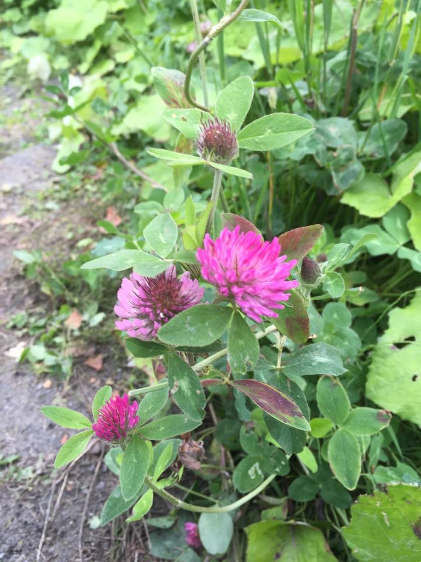
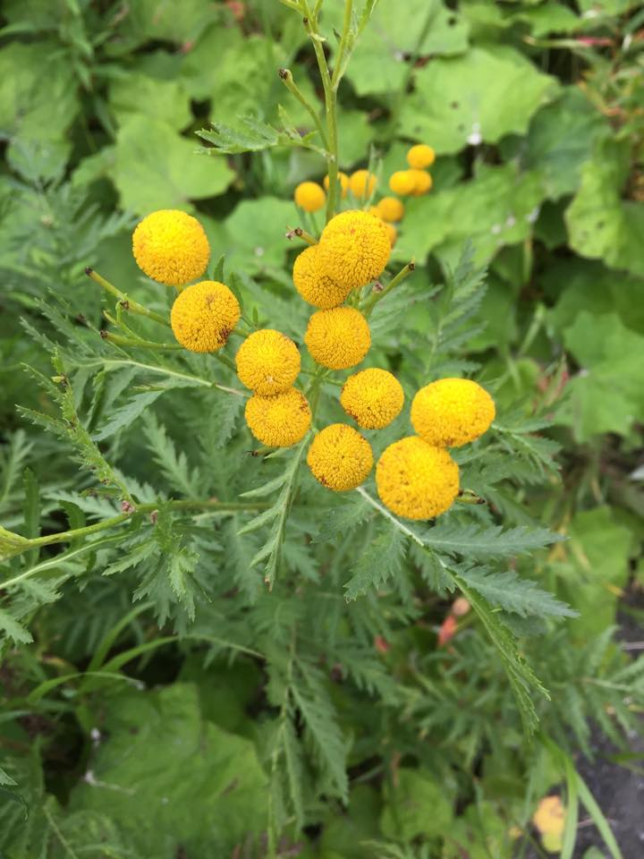

Red clover (Trifolium pratense) Tansy (Tanacetum vulgare)

A specie in area 1
Tansy is a 60-80 cm plant in the Asteraceae familiy.
It is scanty and smells spicy. It doesn’t branch. The leaves look like fins and are serrated. It was origianlly grown i gardens as a medicine plant, but has spread to grow in ditches, by the roads and fields as time has passed. . It blooms during july-august.

Observations in area 2: Short grassy field with heather and willowherb
. These are plants that establish early in the succession prosess, but just a year og two later than the first pioneer plants. The ground is grainy and sandy. The ecosystem is in a slope. It seems poor in nutrients. The ecosystem i turned toward the north and is often windy and cold. It has little protection. There are a mixed number of species, and it may also be in a later stage of succession because of the brush vegetation around. Since most of the plants are short pioneer species among the salix carea, we think it has been used for skiing and sleding in the wintertime. There might be som human interferrence in the area.

Light conditions | Light conditions - Good .
Moisture | Mossy vegetation, moist ground.
Descriptions of environment | Open area with short brush and trees. Lots of moss growing here.
Plant species | Blueberry, lingonberry, willowherb, rasberry, common grasses , Vicia cracca, ferns - gymnocarpium dryopteris,  dwarf cornel / bunchberry (Cornus suecica)
Dominating plants | Grass, moss and blueberry, (Vaccinium myrtillus)

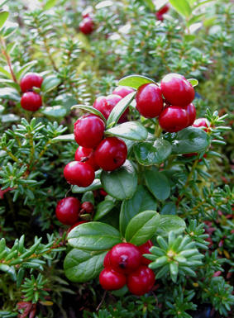

2 species in area 2:
Lingonberry (Vaccinium vitis-idea L.) is a small green plant with red/pinkish berries. It is about ca. 10 cm tall. The flowers are pink or red shaped as a cap. Lingonberry grows mostly wild, and gathers freely in the fall in the Arctic. The fruits are false berries. They are red and sour. It is a popular fruit, which is made to jam and often eaten on bread or served with meat dishes. The berry contains a natural preservative.

Willowherb may be up to 2 meter tall with narrow, spear shaped leaves and a large number of pink/purple flowers. It exists also in white. The flower contains 4 pedals, and 8 long stamens. The flower is male at first, and the stamen matures in order. The lowers flowers opens at first, and these will og into a female phase first and the highest blooms will then be in a male phase. When the seeds are ready, they spread as 100’s from each capsule as white down with the wind.

Observations area 3: Mixed decidious forest

The prosess of succession the deciduous forest has not reached the climax phase. Deciduous forest is dominating the area. There are som young and some old trees in the ecosystem. The trees are very close to eachother, and as a result have thin trunks. The trees will spread out further into the fields around if no human invention takes place. Since the pine forest is located close to this ecosystem, it vil eventually spread their seeds into the deciduous forest. We believe that the forest is in the consolidations phase of the succession prosess.

The a large amount of organic waste that fall on the ground, will rot and nurish the ground, This will also suggest that the soil is moist and moisture is somewhat trapped because of the density of the trees. More organic material on the ground will will maintain moisture, and the soil stays nutrient.
We observe fewer pioneer plants in this forest, only short grass and moss. The type of vegetation demands nourishment and is slow growing. the pioneer plants.

Light conditions | Some light passes through
Moisture | Moist area. Most may be kept from evaporating at a slow speed, because of the density of the trees. Protection from wind may also prevent some evaporation.
Descriptions of enviroment | Tall decidious trees, grass, and other primary still in the area. Moist ground and som fair light conditions.
Plant species | Meadowsweet, Drooping Avens (Geum rivale L.),  ferns (gymnocarpium dryopteris), field horstail (Equisetum arvense), wood sorrel (Oxalis acetosella),  willowherb, common ladies mantle (Alchemilla vulgaris), willow and birch.
Dominerende planter | Willowherb (Epilobium) , birch, willow og ferns.

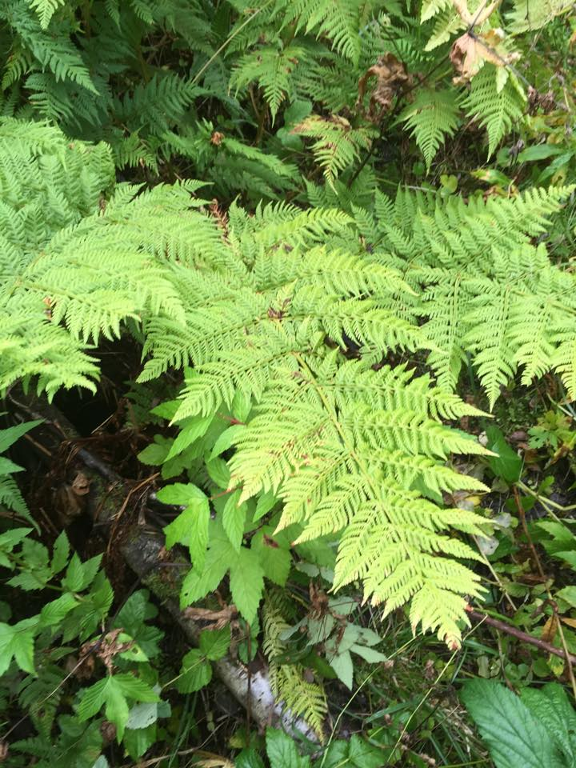

Pteridophyta

2 species in area 3:
A fern is one of a group of roughly 12,000 species of plants belonging to the botanical group known as Pteridophyta. They are vascular plants and have stems and leaves, Ferns reproduce via spores and have neither seeds nor flowers. Most ferns have what are called fiddleheads. The fiddleheads expand into what are called fronds, which are each delicately divided.
Goat willow pussy willow (Salix caprea) is a common species of willow native to Europe, western and central Asia. It’s a deciduous shrub or small tree, reaching a height of 8–10 m (26–33 ft), rarely to 13 m. The leaves are 3-12 cm long and from 2-8 cm wide, broader than most other willows. The flowers are soft silky, and silvery 3-7-cm-long catkins are produced in early spring before the new leaves appear; the male and female catkins are on different plants (dioecious). The male catkins mature yellow at pollen release, the female catkins mature pale green. The fruit is a small capsule 5-10 mm long containing numerous minute seeds embedded in fine, cottony hairs. The seeds are very small (about 0.2 mm) with the fine hairs aiding dispersal; they require bare soil to germinate.

Observations in area 4: Planted norwegian pine forest

This ecosystem is in the climax phase. The norwegian pinetrees are dominating. They were planted by the norwegian government as a plan for subsidies. Some areas of the forest had grassy area with ferns, and other had no vegetation probably because of the sour pH value of the pine needles. The forest is dark in most areas. The ground is dry, because the rain is hindered from hitting the ground.
We believe that in the next hunderd years will reach further out into the other ecosystems in the area. The other vegetaion will probably be gone by then. We believe the forest will be an old forest if the government does not cut it. If they don’t cut it many trees will grow old and some will die. They will then become great biotopes for other species of birds, insects, bacterias and fungii. Maybe one could call each log a small ecosystem.
If the government cuts the forest, there will be more light and new pioneer species will settle. This will lead to a new succession prosess if it’s allowed to grow without any interference. There is some potentional income of the forest for building materials.

The forest has an anthill and we spotted a spider even though its September. One ant is an individualand all the ants in the hill are a population of a specie. The ants a part of an organic community of many species of the forest, which exist in a great food chain. This hill is part of the ecosystem. There are biotic factors and abioitic factors.

Hardly no other trees grow but the norwegian pine. The needles fall from the trees will contruibute to just as much nutrients to the ground as leaves will from a decidious forest. Increased temperature wil increase evaporation.

Light conditions | Shady / poor light conditions
Moisture | More moss and og moist ground.
Descriptions of enviroment | Many old pinetrees with lichens hanging off of them. Lots of moss. In addition the area included saplings of birch and rowan between the large Norwegian pines planted by the government in the 1970s.
Plant species | Birch, rowan, norwegian pine, moss, fungi, oak fern, and golden rod (Asterae)
Dominting plants | Moss, gymnocarpium dryopteris  and golden rods.

A specie in area 4:
Gymnocarpium dryopteris is a fern of the family of Polydoiales. It may create hybrids with other ferns in the area. It is a creeping fern at about 10-30 cm tall, with thin straight trunks. The leaves are ternately-compound pinnae. They live mostly in coiferious woodlands on shale slopes.
Datalogging
Measuring with a data log
 | Temperature (°C) | Moisture (%)
Deciduous forest | 16,1 | 58
Pine forest | 14,5 | 53

Discussion:
- These ecosystems include different species, but some exist in all the ecosystems. .
The shorter pioneer plants will in the long run be conqured by the taller species and individuals. Pine trees will rarely grow in a pioneer community. We will see a just a few scarce pinetrees.
- Over time will the different ecosystems change. New growth of plants and species will settle. The area will change and in the end appear as a stable climax society. That is if the government doent intervene.
- This observation is in agreement with the theory of ecological succession. Species increase the most in the later pioneer phase. The number of species are highest in the consolidation phase, something we noticed at Jaklamyra. The number of species will decrease and eventurally stabilize in the klimax phase

Conclusion:
Area1 is in the latter stage of the pioneer phase, because the plants are tall, but there are short trees. They are just on the outskirts of the field. They have not settled in the field yet.

Area 2 is also in a latter steadium of the pioneer phase. There are heather and mosses, in addition to taller plants and thicket.
Area 3 is in the consolidations phase, because there were tall pionerr plants, decidious trees and large bushes. The trees are tall since we are in the Arctic.
Area 4 is in the climax phase since there were tall pine trees and very few surviving pioneer plants.

Sources/referances:
- Berg, G. A. & Anthon, H (1970) Floraen i farger (3.utg.). Oslo H.Aschehoug & co (W.Nygaard)
- Gjærevoll, O, Jørgensen, R & Lid, D.T. (1997) Fjellflora. Trondheim Keller & Toft A/S
- Heskestad, P.A, Liebich, H, Lerstad, I.K & Engan, A. (2014) Kosmos påbygging
- http://ndla.no/nb/node/60414
- https://snl.no/bregner/bilder#bregner1
- https://snl.no/hengeving
- https://snl.no/bregner

