GEOGRAPHY
Task 2 Lahemaa National Park
Aim: to describe the climate of the national park and analyse the influence of a climate forcing on the climate of the region
Integrated subjects: biology, geography, physics, math Equipment: А4 paper.
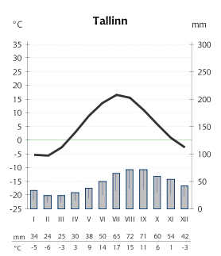
Instructions:
Using the climate chart, describe the climate of the national park.
Average air temperature in January ………………………
Average air temperature in July …………………..……
Annual range of temperature ……………………
Average annual temperatures …………………..……
Average annual precipitation ……….………
Distribution of annual precipitation ……………
…………………………………………………………
…………………………………………………………
…………………………………………………………

In what way has the geographical location of the national park (its distance from the equator, the altitude above the sea level, the distance from the sea, windward/leeward slopes) affected the climate of the region (its temperature, the amplitude of temperature, the amount and spread of precipitation)? Specify which factor has affected which item.
1. The distance from the equator …………………………………………………………………
…………………………………………………………………………………………………
…………………………………………………………………………………………………
2. The altitude above the sea level …………………………………………………………………
…………………………………………………………………………………………………
…………………………………………………………………………………………………
3. The distance from the sea …………………………………………………………………
…………………………………………………………………………………………………
…………………………………………………………………………………………………
4. Windward/leeward slopes ………………………………………………………
…………………………………………………………………………………………………
…………………………………………………………………………………………………
…………………………………………………………………………………………………
…………………………………………………………………………………………………

