GEOGRAPHY
Task 3. Lahemaa National Park
Aim: to consolidate the skill to find various bodies of water in the national park and to describe its geographical location.
Integrated subjects: biology, geography
Instructions: Take a look at a map. What bodies of water are there in Lahemaa National Park? Where are they located?
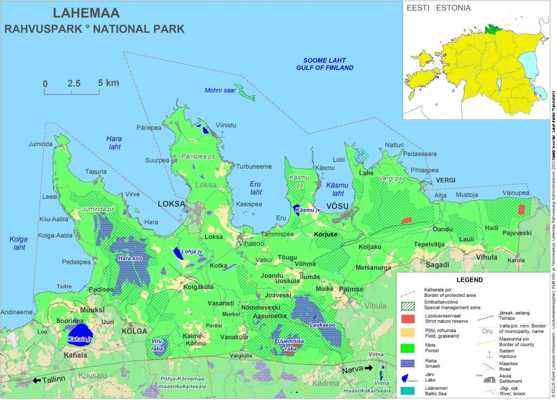
Rivers: …………………………………………………………………………………………
………………………...…………………………………………………………………………
………………………...…………………………………………………………………………
Lakes: …………………………………………………………………………………………
………………………...…………………………………………………………………………
………………………...…………………………………………………………………………
Swamps: …………………………………………………………………………………………
………………………...…………………………………………………………………………
………………………...…………………………………………………………………………

