PHYSICS
Task 4.1: Determination of relative humidity (moisture) of wood species, growing at different altitude above sea level
Relative humidity of wood — it is the ratio of the humidity weight in the wood and the weight of humid wood expressed as a percentage.

Aim: define if the humidity of a wood species depends on the growing altitude above the sea level
Integrated subjects: Biology, Chemistry, Geography, Physics.
Equipment: weight scale 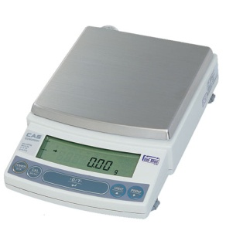, microwave oven
Instructions:
- Choose a wood species which grows at different altitude above sea level
My wood species is ……………………………………………..
- Take 3 wood samples at every altitude above sea level (a branch of cylindrical form, length up to 10 cm) and mark every sample (E.g. A1S1 – altitude 1 sample 1)
- Clean the bark
- Measure the weight of humid wood samples (freshly cut) and record into table 1
Table 1 Weight of humid wood samples
 | Weight of sample 1, m₁(g-gramme) | Weight of sample 2, m₂(g-gramme) | Weight of sample 3, m₃(g-gramme)
Altitude 1 ………….m
Altitude 2 ………….m
Altitude 3 …………m

- Place the samples into the microwave for 15 minutes at 50% of maximum power.
- After 15 minutes take the samples out of the microwave and measure the weight again. Record the data into table 2.
Table 2 Weight of dry wood samples
 | Weight of sample 1, m₁(g-gramme) | Weight of sample 2, m₂(g-gramme) | Weight of sample 3, m₃(g-gramme)
Altitude 1 ………….m
Altitude 2 ………….m
Altitude 3 …………m

- A) Calculate the relative humidity of wood samples using the formula:
$W=\frac{m_{hum}-m_{dry}}{m_{hum}}∙100\%$, where
W- relative humidity of wood expressed as a percentage (%);
$m_{hum}$ – weight of humid wood sample (g);
$m_{dry}$– weight of dry wood sample (g);
Calculations:

B) Record the results into table 3
C) Calculate the average wood humidity for every altitude and record it into table 3
$$W_{av}=\frac{w_{1}+w_{2}+w_{3}}{3}$$
Table 3. Relative humidity of wood
 | Relative humidity 1 of sample W₁ (%) | Relative humidity 2 of sample W₂ (%) | Relative humidity 3 of sample W₃ (%) | Average relative humidity W_{av} (%)
Altitude 1
Altitude 2
Altitude 3

- Based on the average data of relative wood humidity, conclude if humidity depends on the altitude of growing.
Comparison:
……………………………………………………………………………………………………………………………………………………………………………………………………………………………………………………………………………………………………………………………………………………………………………………………………………………………………………………………………………………………………………………………………………………………………………………………………………………………..
Conclusion:
……………………………………………………………………………………………………………………………………………………………………………………………………………………………………………………………………………………………………………………………………………………………………………………………………………………………………………………………………..

