PHYSICS
Task 4.2: Determination of relative humidity (moisture) of wood species, growing in places with different soil humidity (swamp, pine wood)
Relative humidity of wood — it is the ratio of the humidity weight in the wood and the weight of humid wood expressed as a percentage.
Aim: Define if the humidity of a wood species depends on the humidity of soil where it grows
Integrated subjects: Biology, Chemistry, Geography, Physics.
Equipment: weight scale 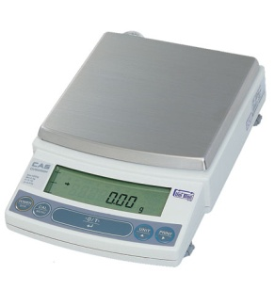, microwave oven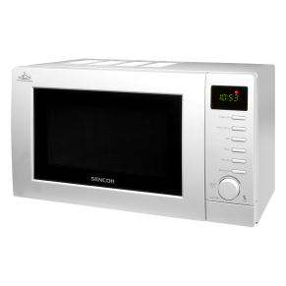
Instructions:
- Choose a wood species which grows at different altitude above sea level
My wood species is ……………………………………………..
- Take three wood samples from a swamp and from a pine wood (a branch of cylindrical form, length up to 10 cm) and mark every sample (E.g. P1S1 – pine wood 1 sample 1)
- Clean the bark
- Measure the weight of humid wood samples (freshly cut) and record into table 1
Table 1 Weight of humid wood samples
 | Weight of sample 1, m₁(g-gramme) | Weight of sample 2, m₂(g-gramme) | Weight of sample 3, m₃(g-gramme)
Pine wood
Swamp

- Place the samples into the microwave for 15 minutes at 50% of maximum power.
- After 15 minutes take the samples out of the microwave and measure the weight again. Record the data into table 2.
Table 2 Weight of dry wood samples
 | Weight of sample 1, m₁(g-gramme) | Weight of sample 2, m₂(g-gramme) | Weight of sample 3, m₃(g-gramme)
Pine wood
Swamp

- A) Calculate the relative humidity of wood samples using the formula:
$W=\frac{m_{hum}-m_{dry}}{m_{hum}}∙100\%$, where
W- relative humidity of wood expressed as a percentage (%);
$m_{hum}$ – weight of humid wood sample (g);
$m_{dry}$– weight of dry wood sample (g);
Calculations:

B) Record the results into table 3
C) Calculate the average wood humidity taken from pine wood and swamp and record it into table 3
$$W_{av}=\frac{w_{1}+w_{2}+w_{3}}{3}$$
Table 3. Relative humidity of wood
 | Relative humidity 1 of sample W₁ (%) | Relative humidity 2 of sample W₂ (%) | Relative humidity 3 of sample W₃ (%) | Average relative humidity W_{av} (%)
Pine wood
Swamp

- Based on the average data of relative wood humidity, conclude how wood humidity depends on the humidity of soil where it grows.
Comparison:
……………………………………………………………………………………………………………………………………………………………………………………………………………………………………………………………………………………………………………………………………………………………………………………………………………………………………………………………………………………………………………………………………………………………………………………………………………………………..
Conclusion:
……………………………………………………………………………………………………………………………………………………………………………………………………………………………………………………………………………………………………………………………………………………………………………………………………………………………………………………………………..

