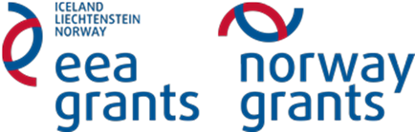

Visit to the Polar Park

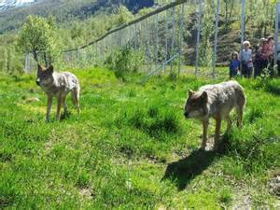

Competence aims:
- plan and carry out different types of investigations by identifying variables, gathering and processing data and writing a report that includes discussions about estimating uncertainties of measurements and assess possible sources of errors

Purpose: You are to produce a brochure, where you choose one or more of the predators at the zoo. You write an informative and interesting brochure for the public. Good structure and in debt knowledge of the subject is important. As a conclusion, the brochure will be presented in class.

The brochure may be used to help the students efficiently find important facts related to a subject in natural science. It may be useful to give a short and effective presentation.
Set up for the brochure: http://www.naturfag.no/artikkel/vis.html?tid=1374256
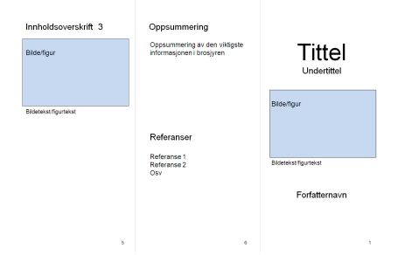
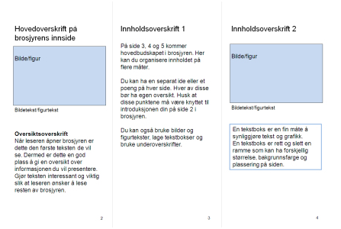

Criteria of assessment
Following please find the criteria for assessment:
- Overall assessment: Is the brochure interesting, informative and objective?
- Terminology: Is the wording precise in order to help the reader understand the theme?
- Organization and structure: Is there a connection of the themes through the brochure?
Is there a logic connection between the paragraphs?
- Correct spelling, grammar and list of reference
Example of a finished brochure
